Estimation and order selection

Maximum likelihood estimation is what R uses t determine the ARIMA model. It simple finds values that maximize the probability of obtaining data we observed. Information criteria tend not to be a good determinate of order of differencing a model, but only for p and q. AICC tends to work the best for these two values.

ARIMA modeling in R

The auto.arima() function in R is a variation on the Hyndman-Khandakar algorithm that uses unit root tests, and minimization of AICC and MLE to obtain an ARIMA model

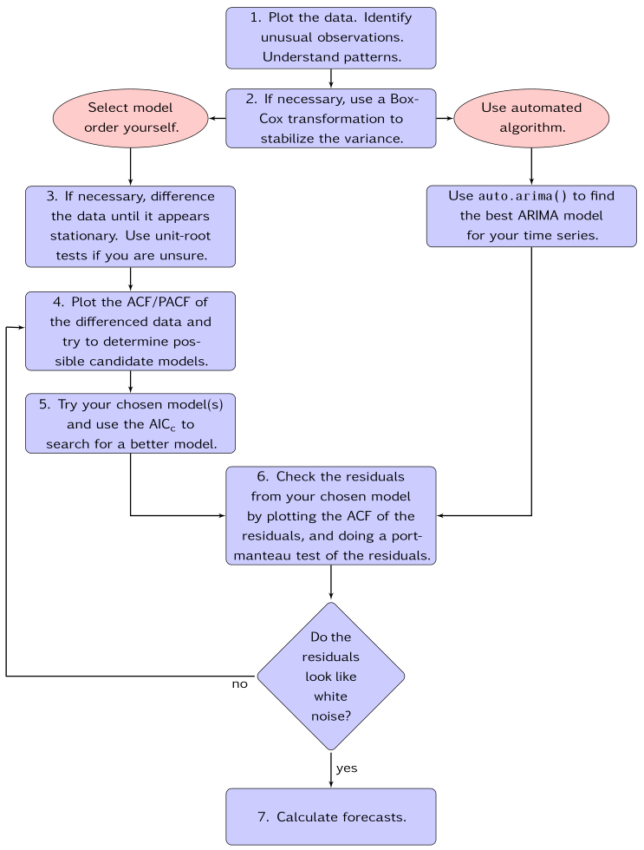

Seasonal ARIMA models

There is a seasonal model for ARIMA:

* (p, d, q) – non-seasonal part
* (P, D Q)m – seasonal part

The “m” is the number of observations per year.